**PO1_DGC_Digital Calculator**

**Keypad CDD Document**

**Version 1.5**

**Proposed**

|  |  |  |  |  |
| --- | --- | --- | --- | --- |
| **Document Change History** | | | | |
| **Version** | **Author** | **Date** | **Change** | **Status** |
| 1.0 | - Alzahraa Mohamed | 24/1/2020 | * Initial creation | Draft |

|  |  |  |  |  |
| --- | --- | --- | --- | --- |
| **Document Change History** | | | | |
| **Version** | **Author** | **Date** | **Change** | **Status** |
| 1.0 | - Nada Mohamed | 3/3/2020 | * Initial creation | Draft |
| 1.1 | - Nada Mohamed | 5/3/2020 | * Adding project Description. * Adding software context diagram. * Adding software Component. * Adding flowchart. * Adding software configurations * Changes in styling format. | Proposed |
| 1.2 | - Nada Mohamed | 5/3/2020 | * Update configuration :   Keypad_ColumnPIN  Keypad_ColumnPORT  Keypad_ROWPIN  Keypad_ROWPORT  As Post build configuration. | Proposed |
| 1.3 | -Nada Mohamed | 7/3/2020 | * Update Software context diagram. * Adding new flowchart inKEYPDAD_errstateGetKeyPressed API Discription. * Update Configuration. * Adding sequence diagram | Proposed |
| 1.4 | -Nada Mohamed | 16/3/2020 | * Change Document name from “CDD Document” to “Keypad CDD Document. * Update sequence diagram. | Proposed |
| 1.5 | -Nada Mohamed | 18/3/2020 | * Update sequence diagram. | Proposed |

|  |  |  |
| --- | --- | --- |
| **Reference Documents** | | |
| **Document Name** | **Version** | **Status** |
| SRS | 1.10 | Proposed |
| GDD | 1.4 | Proposed |

**Table of Contents**

**1.** **Project Description** 6

**1.1** **Software Context Diagram** 6

**2.** **Components** 7

**2.1** **ECUAL API’s** 7

**2.1.1** **KEYPAD** 7

**3.** **Sequence Diagram** 9

**4.** **Configuration** 10

**Index of Figures**

Figure ‎1‑1 Software Context Diagram 6

Figure 2 Keypad Flowchart 8

Figure 3 Sequence Diagram 9

# **Project Description**

This project is a digital calculator that takes input from user and displays the input and the result on a screen.

The hardware used in the calculator is Keypad which takes input from user, LCD to display the result, buzzer to generate tunes on each key press and micro controller that performs all operations in the system.

## **Software Context Diagram**

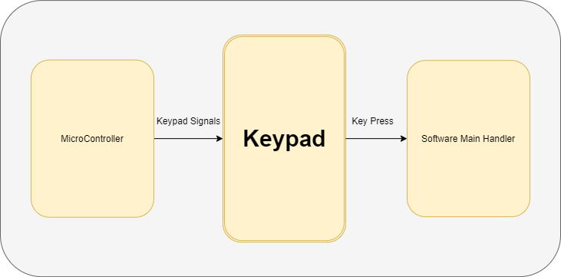

Figure ‎1‑1 Software Context Diagram

# **Components**

Clarifying the components mentioned in the layered architecture, their public API’s, arguments, return value and requirements covered.

## **ECUAL API’s**

### **KEYPAD**

#### Keypad Initiate

|  |  |  |  |
| --- | --- | --- | --- |
| **Requirement ID** | Req_PO1_DGC_ Keypad_CDD _001_V01 | | |
| **Service name:** | KEYPAD_errstatInit | | |
| **Syntax** | errstate KEYPDAD_errstateInit (void) | | |
| **Sync/Async** | Synchronous | | |
| **Description** | This API shall initiate Keypad global veriables. | | |
| **Parameter (in)** | None | | |
| **Parameter (out)** | None | | |
| **Return Value** | errstate | OK : if everything is done correctly  NOK : if anything goes wrong. | Type :- unsigned char  Range : OK = 0U (unsigned char)  NOK = 1U (unsigned char) |
| **Covers** | Req_PO1_DGC_GDD_009_V01 | | |

#### Keypad Get Pressed Key

|  |  |  |  |
| --- | --- | --- | --- |
| **Requirement ID** | Req_PO1_DGC_Keypad_CDD_002_V01 | | |
| **Service name:** | KEYPDAD_errstateGetKeyPressed | | |
| **Syntax** | errstate KEYPDAD_errstateGetKeyPressed (u8 * Copy_u8PtrKey) | | |
| **Sync/Async** | Synchronous | | |
| **Description** | This API shall get the keypad pressed key    Figure 2 Keypad Flowchart | | |
| **Input Argument** | Copy_u8PtrKey: pointer that holds the value of the pressed key | | |
| **Return value** | errstate | OK : if everything is done correctly  NOK : if anything goes wrong. | Type :- unsigned char  Range : OK = 0 (unsigned char)  NOK = 1 (unsigned char) |
| **Covers** | Req_PO1_DGC_GDD_010_V01 | | |

# **Sequence Diagram**

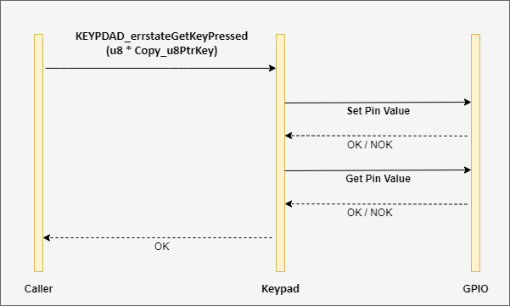

Figure 3 Sequence Diagram

# **Configuration**

|  |  |
| --- | --- |
| **Name** | Keypad_Columns_MaxNumber |
| **Description** | To configure the maximum number of column pins |
| **Value** | 4 |
| **Type** | Unsigned char |
| **Post-Build** | False |
| **Pre-Compile** | True |

|  |  |
| --- | --- |
| **Name** | Keypad_Column_0_PORT |
| **Description** | To configure the column 0 port of Keypad . |
| **Range** | ‘A’..’D’ |
| **Type** | Unsigned char |
| **Post-Build** | False |
| **Pre-Compile** | True |

|  |  |
| --- | --- |
| **Name** | Keypad_Column_1_PORT |
| **Description** | To configure the column 1 port of Keypad . |
| **Range** | ‘A’..’D’ |
| **Type** | Unsigned char |
| **Post-Build** | False |
| **Pre-Compile** | True |

|  |  |
| --- | --- |
| **Name** | Keypad_Column_2_PORT |
| **Description** | To configure the column 2 port of Keypad . |
| **Range** | ‘A’..’D’ |
| **Type** | Unsigned char |
| **Post-Build** | False |
| **Pre-Compile** | True |

|  |  |
| --- | --- |
| **Name** | Keypad_Column_3_PORT |
| **Description** | To configure the column 3 port of Keypad . |
| **Range** | ‘A’..’D’ |
| **Type** | Unsigned char |
| **Post-Build** | False |
| **Pre-Compile** | True |

|  |  |
| --- | --- |
| **Name** | Keypad_Rows_MaxNumber |
| **Description** | To configure the maximum number of row pins |
| **Value** | 4 |
| **Type** | Unsigned char |
| **Post-Build** | False |
| **Pre-Compile** | True |

|  |  |
| --- | --- |
| **Name** | Keypad_ROW_0_PORT |
| **Description** | To configure the row 0 port of Keypad . |
| **Range** | ‘A’..’D’ |
| **Type** | Unsigned char |
| **Post-Build** | False |
| **Pre-Compile** | True |

|  |  |
| --- | --- |
| **Name** | Keypad_ROW_1_PORT |
| **Description** | To configure the row 1 port of Keypad . |
| **Range** | ‘A’..’D’ |
| **Type** | Unsigned char |
| **Post-Build** | False |
| **Pre-Compile** | True |

|  |  |
| --- | --- |
| **Name** | Keypad_ROW_2_PORT |
| **Description** | To configure the row 2 port of Keypad . |
| **Range** | ‘A’..’D’ |
| **Type** | Unsigned char |
| **Post-Build** | False |
| **Pre-Compile** | True |

|  |  |
| --- | --- |
| **Name** | Keypad_ROW_3_PORT |
| **Description** | To configure the row 3 port of Keypad . |
| **Range** | ‘A’..’D’ |
| **Type** | Unsigned char |
| **Post-Build** | False |
| **Pre-Compile** | True |

|  |  |
| --- | --- |
| **Name** | Keypad_Column_0_PIN |
| **Description** | To configure the pin of keypad column 0 . |
| **Range** | 0..7 |
| **Type** | Unsigned char |
| **Post-Build** | False |
| **Pre-Compile** | True |

|  |  |
| --- | --- |
| **Name** | Keypad_Column_1_PIN |
| **Description** | To configure the pin of keypad column 1 . |
| **Range** | 0..7 |
| **Type** | Unsigned char |
| **Post-Build** | False |
| **Pre-Compile** | True |

|  |  |
| --- | --- |
| **Name** | Keypad_Column_2_PIN |
| **Description** | To configure the pin of keypad column 2 . |
| **Range** | 0..7 |
| **Type** | Unsigned char |
| **Post-Build** | False |
| **Pre-Compile** | True |

|  |  |
| --- | --- |
| **Name** | Keypad_Column_3_PIN |
| **Description** | To configure the pin of keypad column 3 . |
| **Range** | 0..7 |
| **Type** | Unsigned char |
| **Post-Build** | False |
| **Pre-Compile** | True |

|  |  |
| --- | --- |
| **Name** | Keypad_ROW_0_PIN |
| **Description** | To configure the pin of keypad row 0 . |
| **Range** | 0..7 |
| **Type** | Unsigned char |
| **Post-Build** | False |
| **Pre-Compile** | True |

|  |  |
| --- | --- |
| **Name** | Keypad_ROW_1_PIN |
| **Description** | To configure the pin of keypad row 1 . |
| **Range** | 0..7 |
| **Type** | Unsigned char |
| **Post-Build** | False |
| **Pre-Compile** | True |

|  |  |
| --- | --- |
| **Name** | Keypad_ROW_2_PIN |
| **Description** | To configure the pin of keypad row 2 . |
| **Range** | 0..7 |
| **Type** | Unsigned char |
| **Post-Build** | False |
| **Pre-Compile** | True |

|  |  |
| --- | --- |
| **Name** | Keypad_ROW_3_PIN |
| **Description** | To configure the pin of keypad row 3 . |
| **Range** | 0..7 |
| **Type** | Unsigned char |
| **Post-Build** | False |
| **Pre-Compile** | True |

|  |  |
| --- | --- |
| **Name** | Keypad_NotPressed |
| **Description** | To configure value to represent that keypad not pressed yet. |
| **Value** | 0xff |
| **Type** | Unsigned char |
| **Post-Build** | False |
| **Pre-Compile** | True |

|  |  |
| --- | --- |
| **Name** | KEYPAD_ARRAY_KEYS |
| **Description** | To configure value to represent that keypad not pressed yet. |
| **Value** | { [ 1 ,2 , 3 , A ], [ 4 , 5 , 6 , B ], [ 7 , 8 , 9 , C ], [ * , 0 , # , D ] } |
| **Type** | Unsigned char |
| **Post-Build** | False |
| **Pre-Compile** | True |

|  |  |
| --- | --- |
| **Name** | KEYPAD_ROWS_PORTS |
| **Description** | To configure all rows port represented as array |
| **Type** | Unsigned char |
| **Post-Build** | False |
| **Pre-Compile** | True |

|  |  |
| --- | --- |
| **Name** | KEYPAD_ROWS_PINS |
| **Description** | To configure all rows pins value represented as array |
| **Type** | Unsigned char |
| **Post-Build** | False |
| **Pre-Compile** | True |

|  |  |
| --- | --- |
| **Name** | KEYPAD_COLUMNS_PORTS |
| **Description** | To configure all columns port value represented as array |
| **Type** | Unsigned char |
| **Post-Build** | False |
| **Pre-Compile** | True |

|  |  |
| --- | --- |
| **Name** | KEYPAD_COLUMNS_PINS |
| **Description** | To configure all column pins value represented as array |
| **Type** | Unsigned char |
| **Post-Build** | False |
| **Pre-Compile** | True |